Plot Observation
- From the DIMA home screen, select your Plot of interest and click Edit Plot.
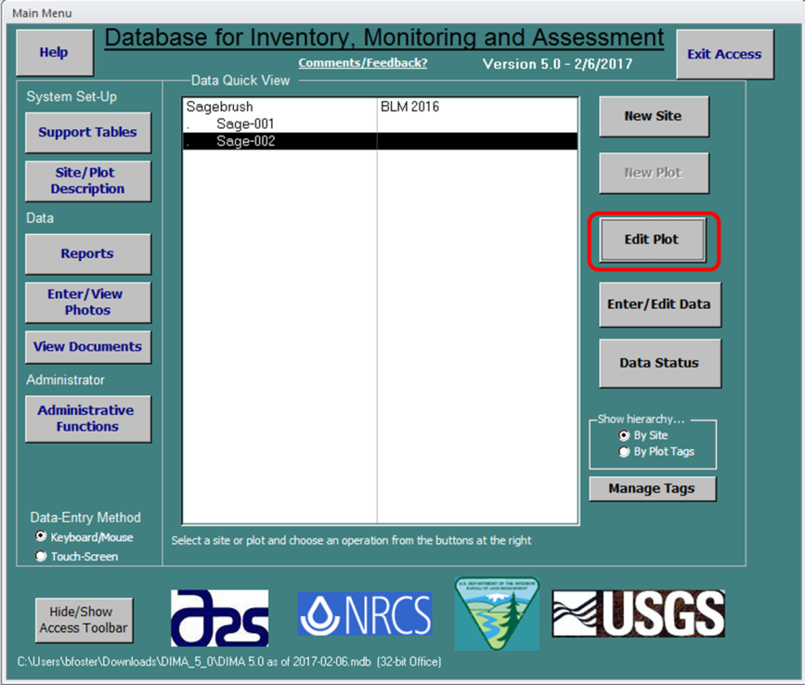

- Select the Plot Observation History and click New to begin the Plot Observation form. The Plot Observation form provides valuable metadata to a site to help explain qualitative data findings.
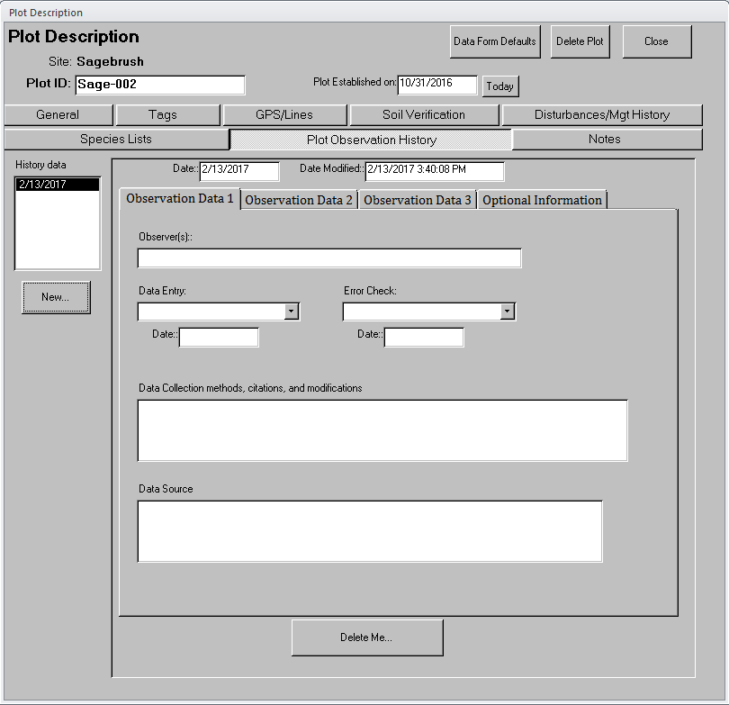
- In the tab Observation Data 1, ensure that Date and Date Modified are correct. Then enter all Observers at the Plot as well as person responsible for Data Entry and Error Check as well as the dates they were performed. Note that there person performing the Error Check should be different from the Data Entry.
- In the tab Observation Data 1, enter all Data Collection methods, citations, and modifications. For example Line-Point Intercept, and Soil Stability using methods described in Monitoring Manual for Grassland, Shrubland, and Savanna Ecosystems. Enter any data sources such as climate data sites in Data Source.
- In the tab Observation Data 2, enter precipitation information being sure to indicate whether the data is in centimeters or inches. On this tab you will also enter all photographs taken indicating the number as it reads when submitting the photographs as well as their description e.g. 103-0090 – soil pit.
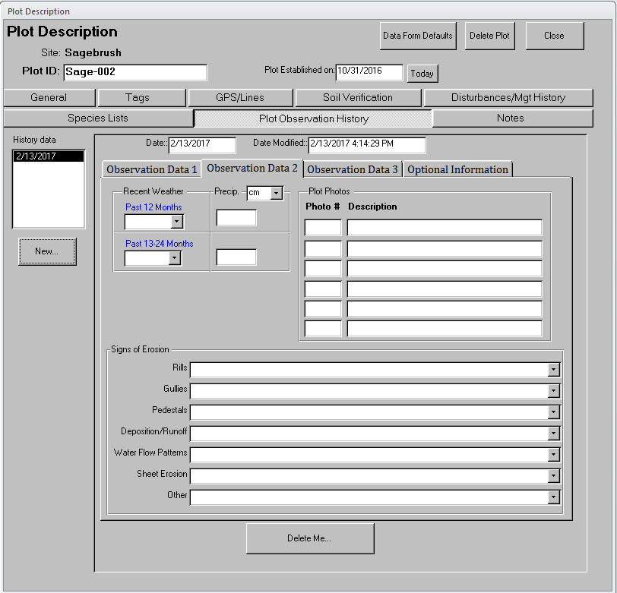
- In the tab Observation Data 2, indicate all signs of erosion found at the Plot.

- In the tab Observation Data 3, describe all evidences of land use, historic use, other known management actions on the Plot, and off-site influences.
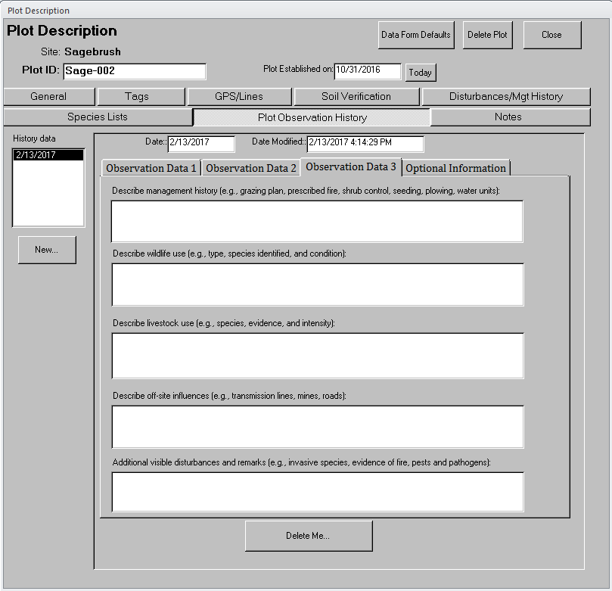
- Use the Optional Information tab for any additional notes about the Plot.

