Unknown Plant Tracking
- From the DIMA home screen, click Support Tables
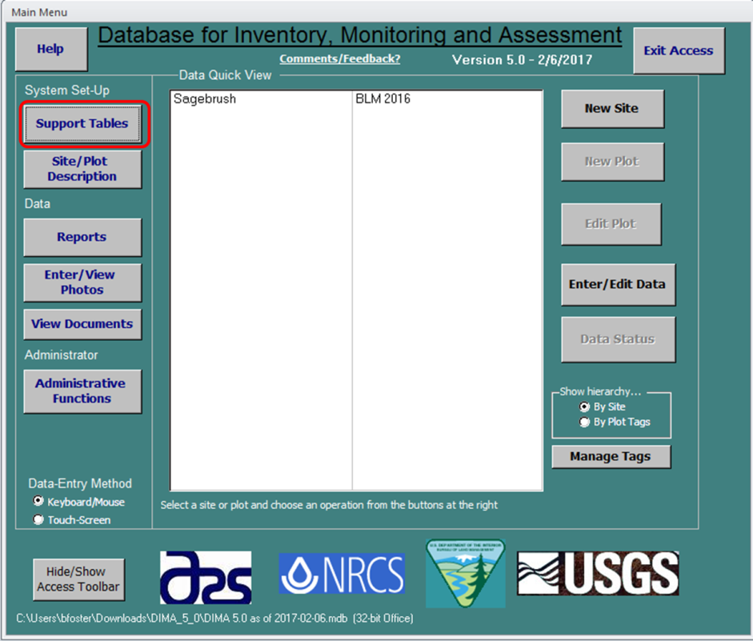

- Select Generic Species Descriptions to navigate to unknown plant data entry.
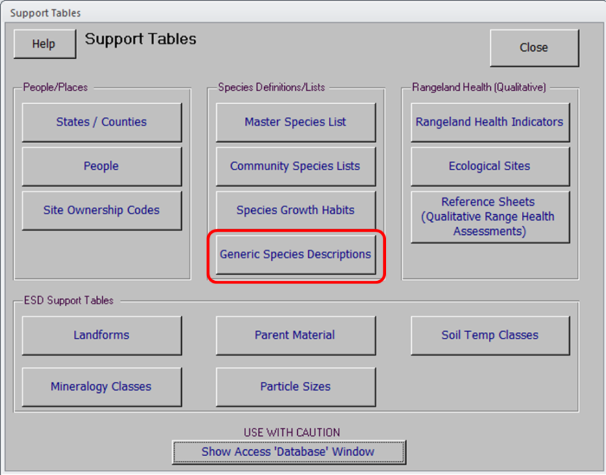

- To enter data in for an unknown plant species, select the Species Code (e.g. AF01). While the Species Code is highlighted, click Maintain Detail to add information about the species.
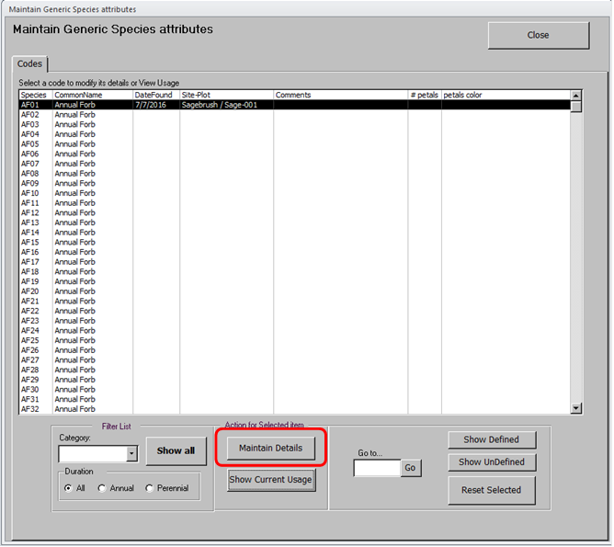

- Enter all known data for the unknown plant species. Click Return to List when complete and to enter additional unknown plant species.
